**User Interface Checkpoint**

Upon arrival to our website, users will be greeted with the following screen. Aside from playing around with the stars in the middle of the screen, users will select to either look at the businesses that have had reviews analyzed by clicking on the top button or users will select to build a profile representative of themselves.

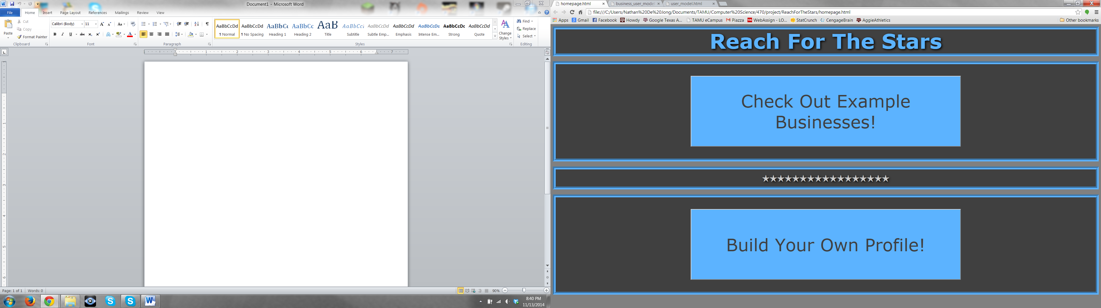

Should users select to view businesses, they will be brought to the screen shown here. We plan to show a sample of the businesses from the Yelp data set that are particularly interesting due to the differences in average Yelp and Semantic score. Users can select any of the radio buttons to populate the tables below. The first table gives general overview information related to the business while the bottom table is a listing of each review with the individual Yelp and Semantic score related to each review. Please note that for the purposes of this checkpoint, the data is fake and thus is not necessarily accurate to what it should be.

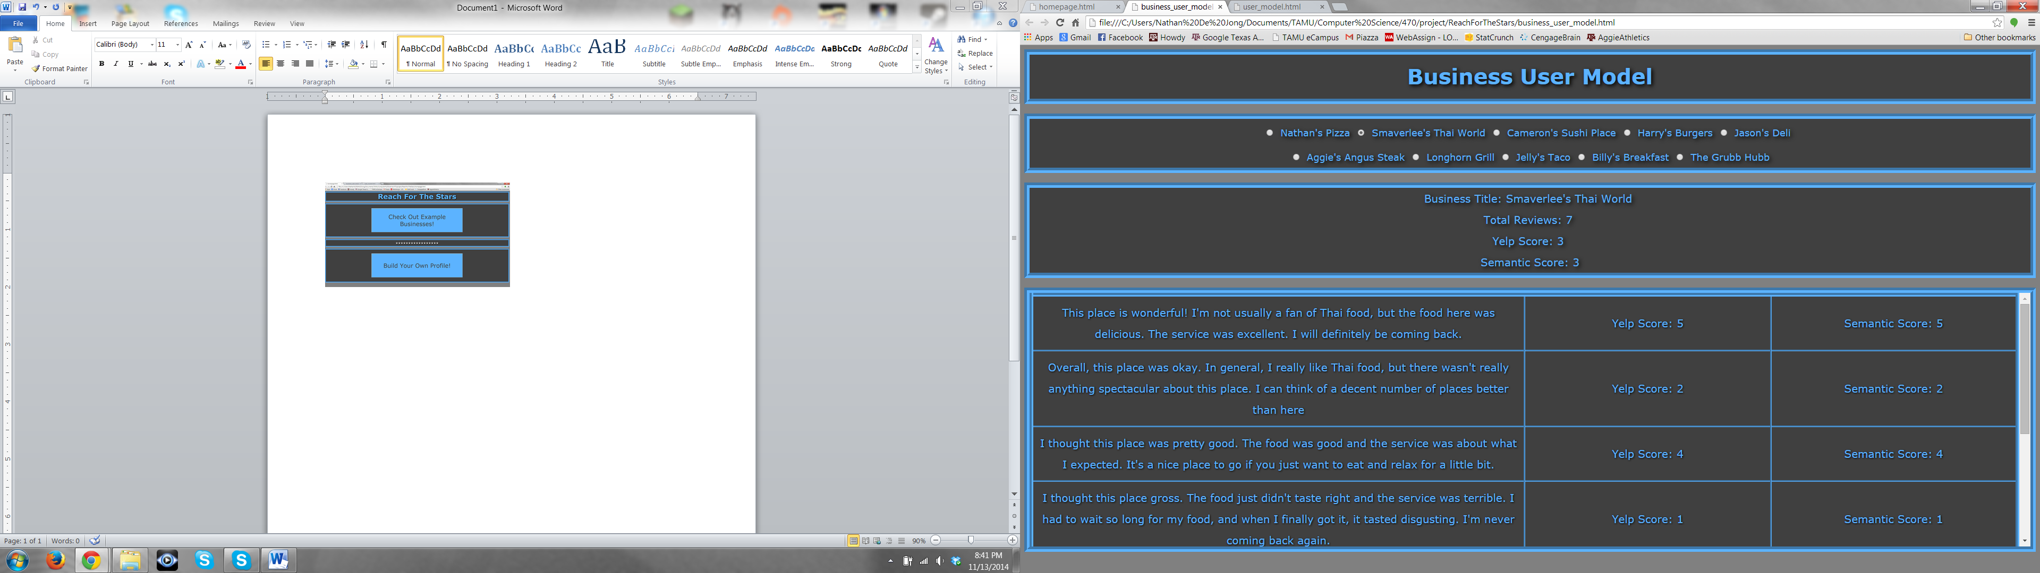

Should users select to build their own profile, they will be brought to the screen shown here. This screen allows users to type the text of a review and select a score from 1 to 5 stars. The predicted score box updates after each typed word. In the final product, this will constantly update in regard to the semantic score of the text being type. Currently however, the predicted score is simple a word count of the total number of words within the text box. As users submit reviews and scores, a profile will be built for them. This profile is visible through the population of the table at the bottom. This gives our project a very interactive element that allows users to experience first hand what kind of ranking our project acomplishes. Please again note that for the purposes of this checkpoint, the data is fake and thus is not necessarily accurate to what it should be.

